
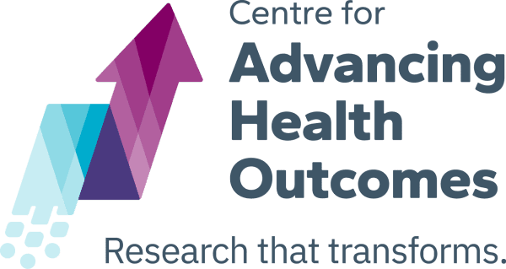




New Analysis Reveals Alberta Study on Closure of the Red Deer Supervised Consumption Site is Deeply Flawed

A new peer-reviewed analysis of a study on Alberta supervised consumption sites outlines major methodological flaws, undisclosed conflicts and links to Alberta’s government, and misleading statements by the study’s authors

[October 5, 2026] A coalition of leading researchers from across Canada published an analysis and accompanying commentary in the International Journal of Drug Policy outlining major flaws and other issues with a study published by researchers with Alberta’s Centre of Recovery Excellence (CoRE) describing the impacts of the closure of a supervised consumption site (SCS) in Red Deer, Alberta.

The original paper in question was published in the scientific journal Addiction earlier this year, and suggested that the closure of the SCS in Red Deer was associated with increased enrollment in opioid agonist treatment. The authors attempted to also look at changes in mortality and other outcomes, but were unable to do so.

After external review, the paper was deemed to be so deeply flawed that 25 Canadian researchers working in the substance use field subsequently wrote to the editors of Addiction, calling for the paper to be fully retracted. Their request was denied. In response, several of those who made the request for retraction subsequently published their concerns, outlining the considerable flaws of the Alberta paper in the commentary published in the International Journal of Drug Policy.

Among the problems were a range of methodological flaws, undisclosed conflicts of interest, links to Alberta’s government that were not disclosed, and statements by the authors, including the lead author, misrepresenting the study findings.

Other concerns include the failure to account for the rollout of programs designed to reduce negative impacts of the closure, including the implementation of a street-based overdose response team and mobile addiction treatment clinic near the former site of the SCS in the period when it was closed, which could explain much of the study’s findings. Furthermore, the study’s lead author oversaw the implementation of these services in his role as Alberta’s provincial medical director of addiction services, making the lack of disclosure of such programs from the analysis concerning.

Also concerning was a misrepresentation of the authorship group’s institution, the Centre on Recovery Excellence (CoRE). Though the authors explicitly state that CoRE was independent of the Alberta government, the CEO of CoRE is appointed by, and directly reports to, the province’s Minister of Mental Health and Addictions. This undermines their stated claims of research independence. This was accompanied by a range of other undisclosed conflicts of interest by the authors, including their roles in overseeing substance use service delivery in Alberta, including the closure of the site.

“Scientific evidence on supervised consumption services should be rigorous, and it should be conducted by scientists and research institutions that are free from political interference,” said the study’s lead author, Dr. Thomas Kerr, Professor and Head of Division of Social Medicine at the University of British Columbia. “We have grave concerns about the Alberta study, given its methodological errors and the failure of its authors to disclose that it was done on behalf of a wing of the Alberta government intent on shutting down supervised consumption services in that province.”

This case sheds further light on the challenges related to communicating the scientific record on effective overdose prevention interventions. Given that the Alberta study was used to justify the closure of supervised consumption services by the governments of Alberta and Ontario, it also reveals how flawed scientific reports can lead to concerning policy decisions. There is therefore a need for more effective and impartial scientific retraction processes, as well as efforts to minimize instances of potential research misconduct in the drug policy space.

A full copy of the analysis and commentary can be found here [link].

-30-

For more information or to schedule an interview with one of the study authors, please contact:

Tanisha Palmer, Centre on Drug Policy Evaluation
Cell: 647-286-0341
Email: tanisha.palmer@unityhealth.to

